AGENDA - Little Hoole Parish Council
Members of the Council are summoned to the Parish Council Meeting to be held on
Mon 12th February 2024 at 7pm,
The Lounge, Walmer Bridge Village Hall, Gill Lane, Walmer Bridge.
Paul Cafferkey, Clerk & Responsible Financial Officer

- Apologies for absence
- To agree the Minutes of the last Parish Council Meeting
- To receive declarations of interest
- Matters arising from the minutes of last meeting
  - Public Time: to invite and listen to issues raised by members of the public
  - Planning Applications:
    - 2 Hall Carr Lane Walmer Bridge PR4 5RA, Application for a lawful development certificate for a proposed detached garage to rear
  - To approve the following transactions in the bank for Jan 2024.
Current a/c Jan 2024
Date | Payee | £ | Description
02-Jan-24 | Direct Debit (GOCARDLESS) | 36.96 | Monthly website subscription
11-Jan-24 | HMRC VTR | -3,130.66 | VAT reclaim 2021/22 & 2022/23
12-Jan-24 | B/P to: Paul Cafferkey | 64.65 | Clerk's Expenses Tax Month 10
12-Jan-24 | B/P to: Paul Cafferkey | 357.72 | Clerk's Salary Tax Month 10
Instant Access a/c Jan 2024
Nil transactions

  - Payments for approval - Clerk’s claim for Jan 2024
  - Payments approved by email or pre-approved and retrospectively noted - None
  - To approve financial statement as at 31st Jan 2024
  - Proposal for use of Bio Diversity grant monies
  - Proposal for summer planting
  - Discussion and suggestion on how to keep new bus shelters clean
  - Dog Waste Bin, Dob Lane Recreation Ground – Update
  - VAT Return – Update
  - To discuss the possible purchase of two additional SPiDs (Speed Indicator Devices)
  - Speed awareness signs project – Update
  - Public Rights of Way work - volunteers
  - To discuss the location (venue) of future parish council meetings
  - To review and approve calendar of key decisions and responsibilities
  - Correspondence, None
  - Information and Updates
  - To agree the date, time and venue for the Mar 2024 meeting

Members of the public are welcome to attend meetings to raise any relevant matters. Alternatively, if you cannot attend the meeting but wish to raise a matter or ask a question, this can be done on your behalf by contacting the Parish Clerk (Paul Cafferkey) via email at or mobile phone 07966267186.

Scan me to go the Little Hoole Parish Council Website, or visit https://www.littlehooleparishcouncil.org.uk/
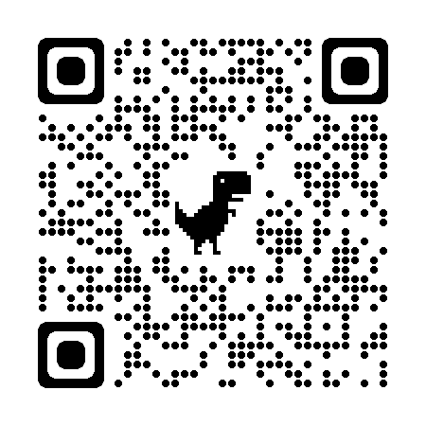
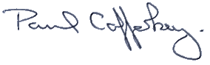
Prepared and approved by Paul Cafferkey, Clerk – Little Hoole Parish Council,
5 Feb 2024

